Use Cases

for

**Shop Online Watches System**

**Version 1.0 approved**

**Prepared by Huynh Nhat Minh CE140197**

**Le Minh Nghia CE140071**

**Ton Tu Trinh CE140257**

**Nguyen Trung Hien CE140412**

**FPT University**

**Saturday, October 22, 2020**

Revision History

|  |  |  |  |
| --- | --- | --- | --- |
| **Name** | **Date** | **Reason For Changes** | **Version** |
| Huynh Nhat Minh, Le Minh Nghia, Ton Tu Trinh, Nguyen Trung Hien | Saturday, October 22, 2020 | initial draft | 1.0 draft 1 |
|  |  |  |  |

# Use Case:

## 1. Function1 /Diagram:

**Figure 3-0**: Use case Diagram

Use Case List

|  |  |  |
| --- | --- | --- |
| **ID** | **Actor** | **Name Use Case** |
| UC-1 | Customer | View products |
| UC-2 | Customer | View details product |
| UC-3 | Customer | Order products |
| UC-4 | Customer | Save product customer has added a shopping cart |
| UC-5 | Customer | Account Manager |
| UC-6 | Admin | Product Manager |
| UC-7 | Admin | Categories Manager |
| UC-8 | Admin | Employee Manager |
| UC-9 | Admin | Image Manager |
| UC-10 | Admin | Supplier Manager |
| UC-11 | Admin | View Reports |

### 1.1 UC01 – View Product

#### Screen Design

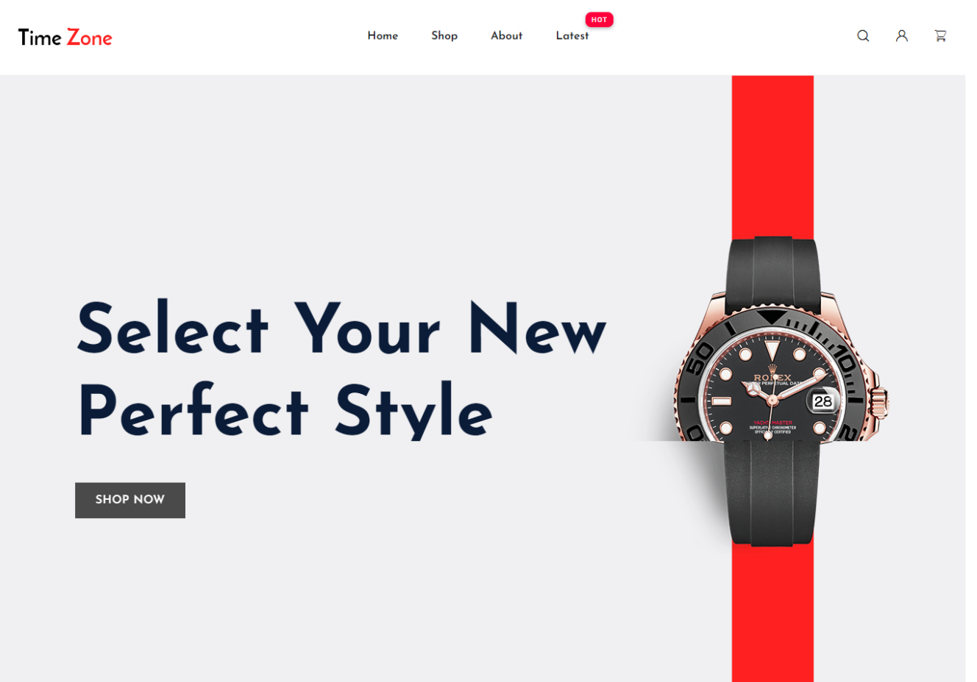

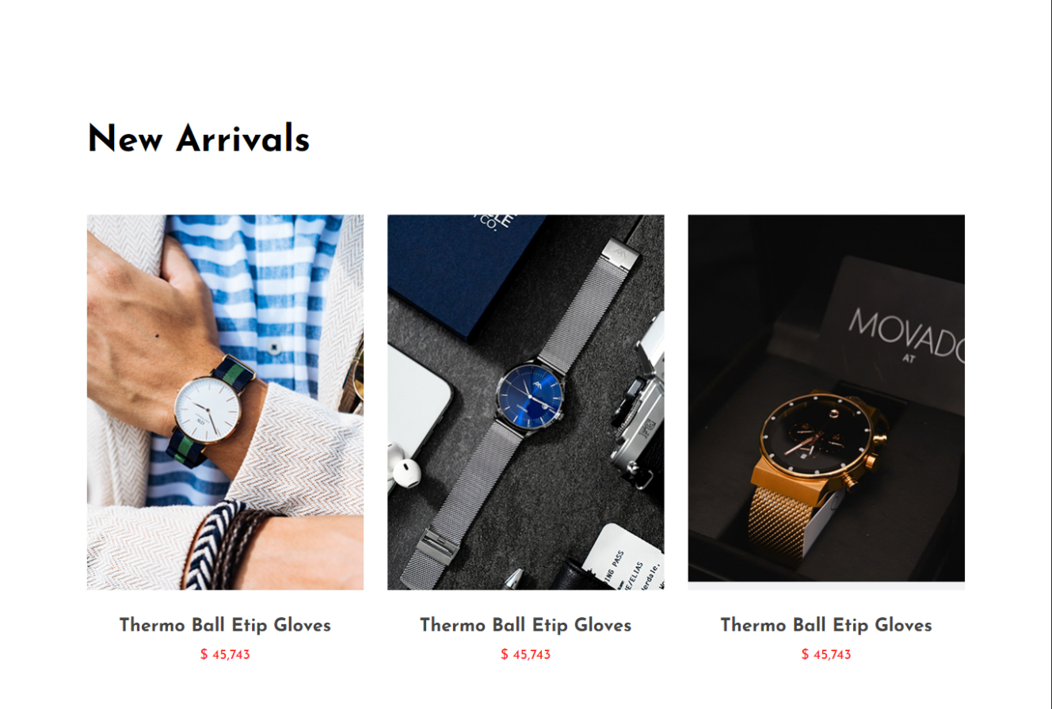

**Figure 3-1**: Screen Design of View Product

#### Use Case Specification

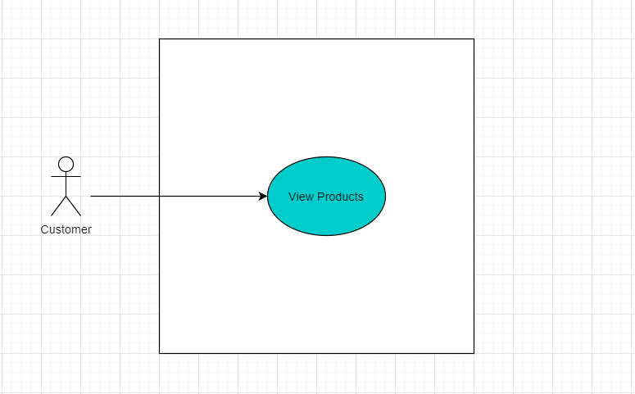

**Figure 3-2:** View Products Use-Case Diagram

|  |  |  |  |
| --- | --- | --- | --- |
| UC ID and Name: | UC-1 View products | | |
| Created By: | Huynh Nhat Minh | Date Created: | 10/20/2020 |
| Primary Actor: | Customer | Secondary Actors: |  |
| Trigger: | Customers on the site see the list of products | | |
| Description: | Customers visit the home page interface to see the outstanding products in the store | | |
| Preconditions: | **PRE-1.1** Customers visit the website and view outstanding products | | |
| Postconditions: | **POST-1.1** At the end of the use case, all images, information, and news with the sales system are restarted. | | |
| Normal Flow: | View product   1. Customers visit the website 2. See featured products | | |
| Alternative Flows: | N/A | | |
| Exceptions: | N/A | | |
| Priority: | High | | |
| Frequency of Use: | Every day | | |
| Business Rules: | N/A | | |
| Other Information: | N/A | | |
| Assumptions: | Assumes that 3 customers have visited the web site and viewed information about the products | | |

### 1.2 UC02 – View Details Product

#### Screen Design

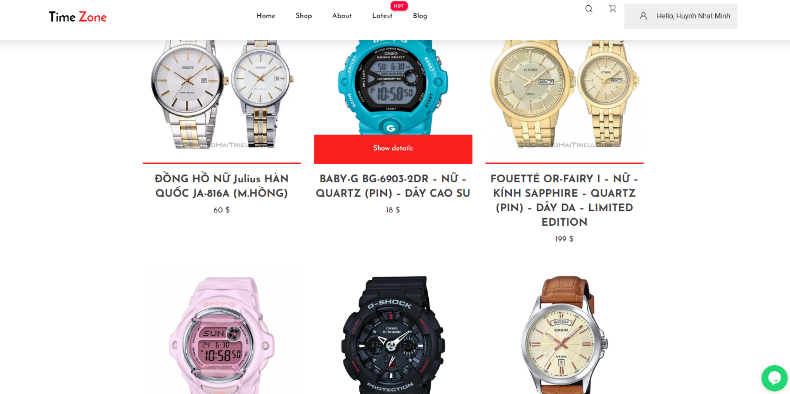

**Figure 3-3**: Screen Design of View Details Products

#### Use Case Specification

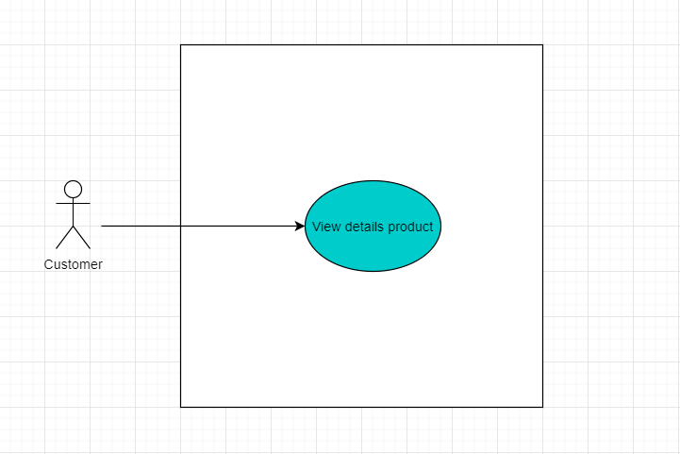

**Figure 3-4:** View details product Use-Case Diagram

|  |  |  |  |
| --- | --- | --- | --- |
| UC ID and Name: | UC-2 View details product | | |
| Created By: | Huynh Nhat Minh | Date Created: | 10/20/2020 |
| Primary Actor: | Customer | Secondary Actors: |  |
| Trigger: | Customers on the site view detail the list of products | | |
| Description: | From the Home page interface, customers can access the Shop interface page to view detailed information about a product. | | |
| Preconditions: | **PRE-1.1** Customers visit the website and view details of outstanding products | | |
| Postconditions: | **POST-1.1** At the end of the use case, all images, information, and news with the sales system are restarted. | | |
| Normal Flow: | View details product   1. Customers access the website 2. Home page interface - > Shop page 3. View detailed information about one product | | |
| Alternative Flows: | N/A | | |
| Exceptions: | N/A | | |
| Priority: | High | | |
| Frequency of Use: | N/A | | |
| Business Rules: | N/A | | |
| Other Information: | N/A | | |
| Assumptions: | Assume that one customer has visited a website and viewed the details of a product such as a price, origin, product description, and selloff. | | |

### 1.3 UC03 – Order Product

#### Screen Design

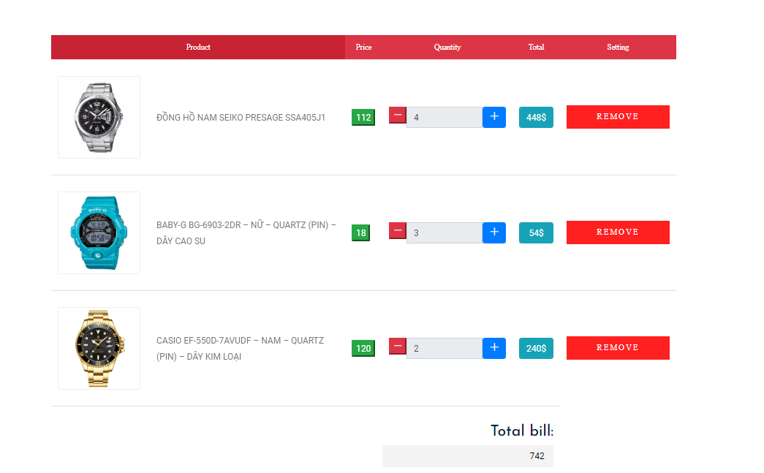

**Figure 3-5**: Screen Design of Order Product

#### Use Case Specification

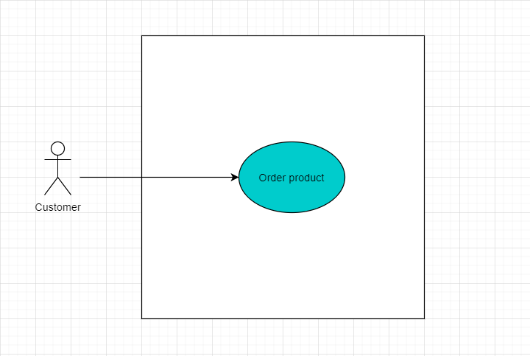

**Figure 3-6:** Order Products Use-Case Diagram

|  |  |  |  |
| --- | --- | --- | --- |
| UC ID and Name: | UC-3 Order product | | |
| Created By: | Huynh Nhat Minh | Date Created: | 10/20/2020 |
| Primary Actor: | Customer | Secondary Actors: |  |
| Trigger: | Mark product request, product comment | | |
| Description: | User searches for products, the system displays a list of products. Choose the right product according to the requirements. Customers check product information, add products, and verify shopping cart. Fill in customer information such as name, phone number, product quantity, type, delivery address, a form of payment. After providing the information, check your order and choose your form of payment. Pay and order, receive a notification on the successful order confirmation | | |
| Preconditions: | **PRE-1.1** Authentication | | |
| Postconditions: | **POST-1.1** Order information is stored on the system and passed on to sales staff and print bill on-screen of the customer. | | |
| Normal Flow: | NF1. Order  1. View product list  2. Select row  3. Number of products  4. Delivery address  5. Form of payment  6. Confirmation information | | |
| Alternative Flows: | **AF1.1** Order and pay with a Digital wallet  1. View product list  2. Select row  3. Number of products  4. Delivery address  5. Payment by e-wallet, the system will deduct directly from the e-wallet  6. Announce successful transaction  **AF1.2** Order and pay with a bank card  1. View product list  2. Select row  3. Number of products  4. Delivery address  5. Payment by bank card, the system will link to the bank gateway, connect with customer account number -> pay minus money directly to the bank account  6. Announce successful transaction | | |
| Exceptions: | The product is not in the system  1. The system displays a message that the product does not exist  2. The system asks customers if they want to find other products (3a or 4a)  3a. Customers send a request to find another product  3b. The system displays a list of products in the system  4a. The client requests to exit  4b. Function exit system | | |
| Priority: | High | | |
| Frequency of Use: | Every day | | |
| Business Rules: | N/A | | |
| Other Information: | N/A | | |
| Assumptions: | Assuming that: A customer has logged in and bought a product, the customer provides information such as phone number, name, and delivery address for the employee and the employee calls to confirm the order. customers wait for the date of receiving the goods from the store | | |

### 1.4 UC04 – Save product customer has added a shopping cart

#### Screen Design



**Figure 3-7**: Screen Design of Add product to cart

#### Use Case Specification

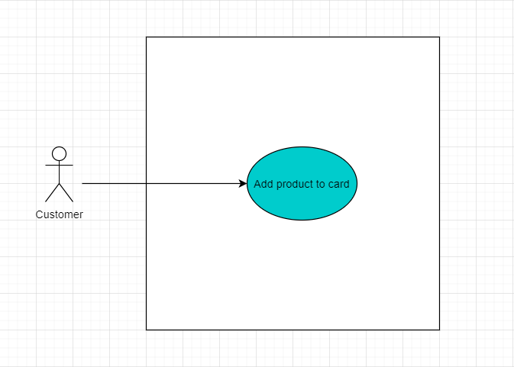

**Figure 3-7:** Add Products to Cart Use-Case Diagram

|  |  |  |  |
| --- | --- | --- | --- |
| UC ID and Name: | UC-4 Save product customer has added a shopping cart | | |
| Created By: | Huynh Nhat Minh | Date Created: | 10/20/2020 |
| Primary Actor: | Customer | Secondary Actors: |  |
| Trigger: | Customer adds one product to cart | | |
| Description: | When customers visit the website, view a product, if they like, they can add that product to the cart but have not paid for the product. | | |
| Preconditions: | **PRE-1.1** The customer adds a favorite product to the cart, the product must remain in the store | | |
| Postconditions: | **POST-1.1** At the end of the use case, products are only saved in the shopping cart when customers are logged into the account. | | |
| Normal Flow: | Save product customer has added a shopping cart   1. View product from the website 2. Login account 3. Add an item to the cart 4. Return to shopping interface | | |
| Alternative Flows: | N/A | | |
| Exceptions: | N/A | | |
| Priority: | Low | | |
| Frequency of Use: | Slow | | |
| Business Rules: | N/A | | |
| Other Information: | N/A | | |
| Assumptions: | Let's say a customer has an account logged in and added one product to the cart | | |

### 1.5 UC05 – Account Manager

#### Screen Design

**Figure 3-8**: Screen Design of Login

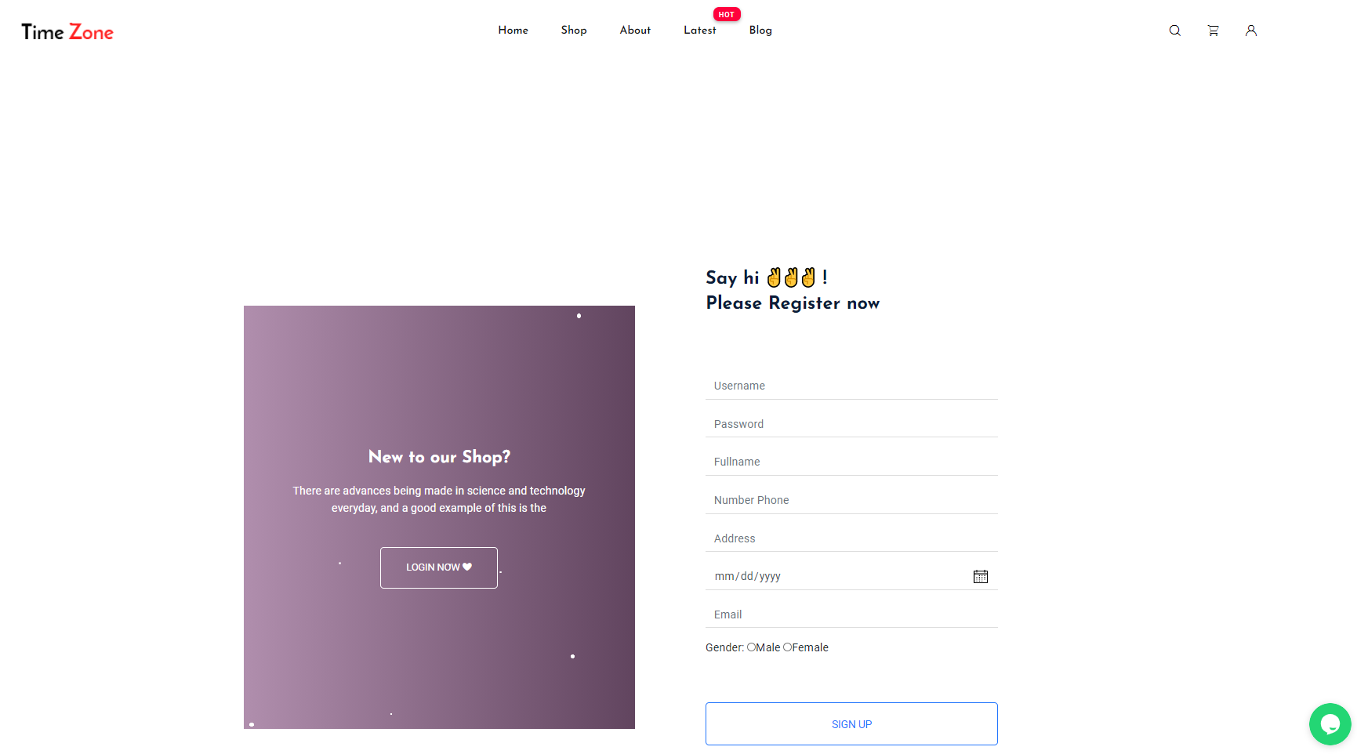

**Figure 3-9**: Screen Design of Register

#### Use Case Specification

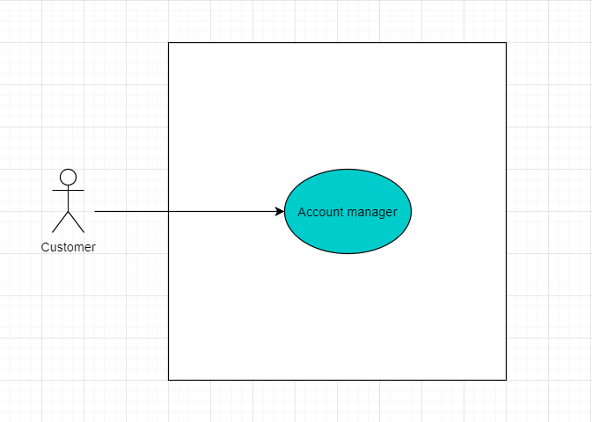

**Figure 3-10:** View Products Use-Case Diagram

|  |  |  |  |
| --- | --- | --- | --- |
| UC ID and Name: | UC-5 Account Manager | | |
| Created By: | Huynh Nhat Minh | Date Created: | 10/20/2020 |
| Primary Actor: | Customer | Secondary Actors: | Admin |
| Trigger: | N/A | | |
| Description: | **Register**: The function allows a user to be able to register in the software when he/she hasn’t registered an account and his/her account is still active.  **Login**: The function allows a user to be able to login to the software when he/she has registered an account and his/her account is still active. | | |
| Preconditions: | **PRE-1.1** Guest has a valid username and password | | |
| Postconditions: | **Register:** When the normal flow completes successfully, a new account is created on the System  **Login:** When the normal flow completes successfully, a new account is created on the System, and the user or admin must be login into the system  **Logout:** When the normal flow completes successfully  **Update**: When the normal flow completes successfully, a new account is updated on the System | | |
| Normal Flow: | **Register account**  1. The client opens the desktop application.  2. The system displays the Home page.  3. Guest click on the Subscribe menu on the navigation bar.  4. The system displays a login/registration dialog.  5. The system displays the registration form in the dialog box.  6. Customers enter their username, full name, date of birth, address, password, and password in the registration form.  7. Guest click the Register button on the registration form.  8. The system creates a new account with the provided field.  9. The system creates an account activation link.  10. The system displays a notification that the account has been activated.  11. The system displays the Home page.  **Login account**   1. Access type URL into the location field of the internet browser and then press enter. 2. User enter user name & password into User Name & Password 3. QS validate the entered user name & password and then display the Home screen   **Logout account**   1. User login on Shop Online Watches System successful 2. User clicks to Button Logout 3. The user will exit the system 4. The system will redirect the user to Home Page   **Update Profile:**  1. User open Shop Online Watches System  2. System display home page.  3. Guest clicks button edit profile menu on the navigation bar.  4. System displays the update form in the dialog box.  5. Guest enters the full name, date of birth, address, password, confirm password on the registration form.  6. Guest clicks Update button on the registration form.  7. System update account with field provided.  8. System generates an activation link for the account.  9. System displays a message to notify that account updated | | |
| Alternative Flows: | System display "Error" page with message "Internal System Error, please contact with administrator" | | |
| Exceptions: | System display "Error" | | |
| Priority: | High | | |
| Frequency of Use: | Every day | | |
| Business Rules: | N/A | | |
| Other Information: | N/A | | |
| Assumptions: | Guest can access his/her account | | |

### 1.6 UC06 – Product Manager

#### Screen Design

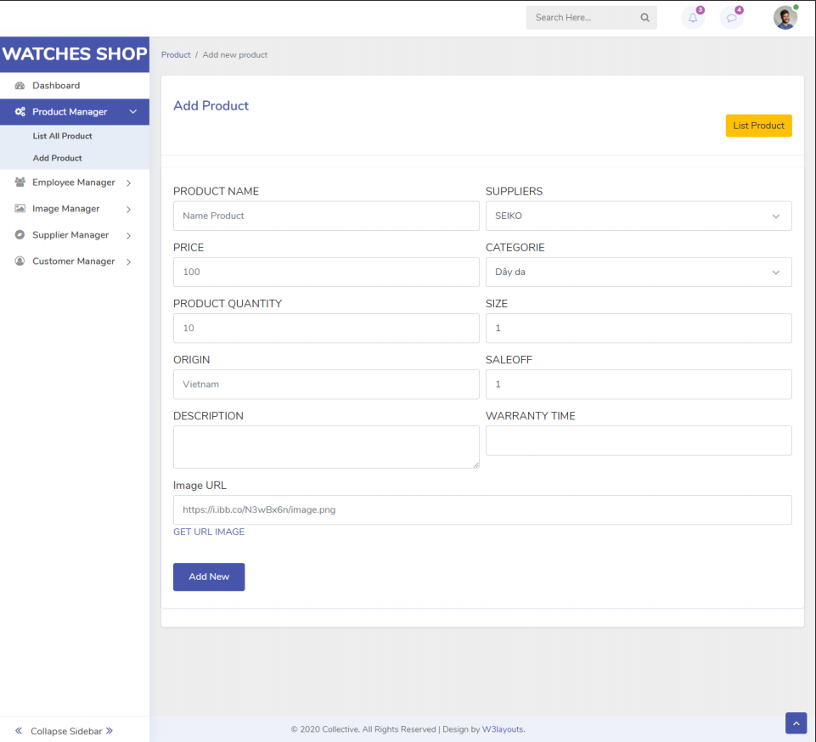

**Figure 3-11**: Screen Design of Add Product

#### Use Case Specification

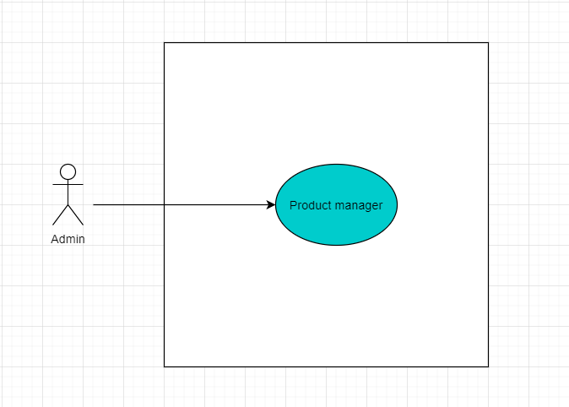

**Figure 3-12:** Products Manager Use-Case Diagram

|  |  |  |  |
| --- | --- | --- | --- |
| UC ID and Name: | UC-6 Product Manager | | |
| Created By: | Huynh Nhat Minh | Date Created: | 10/20/2020 |
| Primary Actor: | Admin | Secondary Actors: |  |
| Trigger: | N/A | | |
| Description: | **Add new product:** Manager login to the “Dashboard”, on the homepage, the manager can add a new product by pressing the product management button on the left toolbar, select the add new product item.  **Edit product:** Manager login to the “Dashboard”, on the homepage, the manager can edit a product by pressing the product management button on the left toolbar, select the edit product item.  **Delete product:** Manager login to the “Dashboard”, on the homepage, the manager can delete a product by pressing the product management button on the left toolbar, select the delete product item. | | |
| Preconditions: | **PRE-1.1** Admin has a valid username and password, login success | | |
| Postconditions: | **POST-1.1** When the normal flow completes successfully, a new product is added, updated, and deleted on the Dashboard page. | | |
| Normal Flow: | **Add a new product**:  1. Admin login to the Dashboard page  2. Click the Product management section, choose to add a new product  3. Fill in product information such as name, quantity, price, sale-off, origin, warranty, size.  4. The system validation the input data values  5. Click the add new product  6. Show information successfully added  **Edit product:**  1. Admin login to the Dashboard page  2. Click the Product management section, choose to edit product  3. Fill in product information such as name, quantity, price, sale-off, origin, warranty, size.  4. The system validation the input data values  5. Click the edit product  6. Show information successfully edited  **Delete product:**  1. Admin login to the Dashboard page  2. Click the Product management section, choose to delete the product  3. The system displays a confirmation message that you want to remove the product or not  4. Click “Yes” or “No”  5.1 If click “Yes” show information successfully deleted.  5.2 If click “No” direction to Home Page | | |
| Alternative Flows: | N/A | | |
| Exceptions: | System display "Error" | | |
| Priority: | High | | |
| Frequency of Use: | Every day | | |
| Business Rules: | N/A | | |
| Other Information: | N/A | | |
| Assumptions: | N/A | | |

### 1.7 UC08 – Employee Manager

#### Screen Design

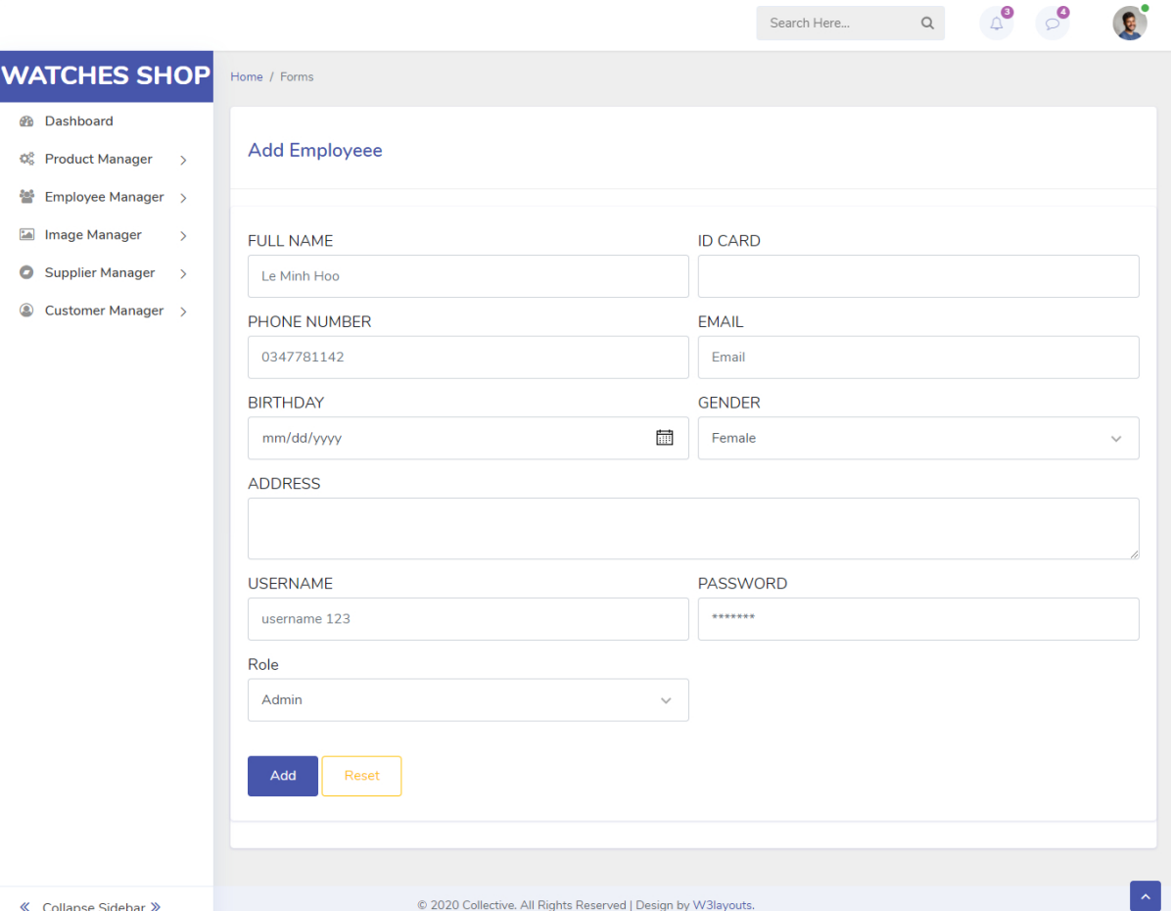

**Figure 3-13**: Screen Design of Add new Employee

#### Use Case Specification

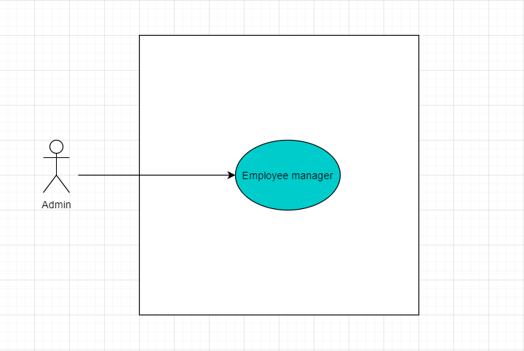

**Figure 3-14:** View Products Use-Case Diagram

|  |  |  |  |
| --- | --- | --- | --- |
| UC ID and Name: | UC-8 Employee Manager | | |
| Created By: | Huynh Nhat Minh | Date Created: | 10/20/2020 |
| Primary Actor: | Admin | Secondary Actors: |  |
| Trigger: | N/A | | |
| Description: | **Add new Employee:** Manager login to the “Dashboard”, on the homepage, the manager can add a new Employee by pressing the Employee management button on the left toolbar, select the add new Employee.  **Edit Employee:** Manager login to the “Dashboard”, on the homepage, the manager can edit an Employee by pressing the catalogs management button on the left toolbar, select the Edit Employee.  **Delete Employee:** Manager login to the “Dashboard”, on the homepage, the manager can delete an Employee by pressing the product management button on the left toolbar, select the delete Employee. | | |
| Preconditions: | **PRE-1.1** Guest has a valid username and password | | |
| Postconditions: | **POST-1.1** When the normal flow completes successfully, a new Employee is added, updated, and deleted on the Dashboard page. | | |
| Normal Flow: | **Add new categories**:  1. Admin login to the Dashboard page  2. Click the Product management section, choose to add a new Employee  3. Fill in product information such as username, password, full name, address, phone, id card, email, gender, birthday.  4. The system validation the input data values  5. Click the add new Employee  6. Show information successfully added  **Edit categories:**  1. Admin login to the Dashboard page  2. Click the Product management section, choose to edit categories  3. Fill in product information such as password, full name, address, phone, id card, gender, birthday.  4. The system validation the input data values  5. Click the edit Employee  6. Show information successfully edited  **Delete catalogs:**  1. Admin login to the Dashboard page  2. Click the Employee management section, choose to delete Employee  3. The system displays a confirmation message that you want to remove the catalogs or not:  4. Click “Yes” or “No”  5.1 If click “Yes” show information successfully deleted.  5.2 If click “No” direction to Home Page | | |
| Alternative Flows: | N/A | | |
| Exceptions: | System display "Error" | | |
| Priority: | Low | | |
| Frequency of Use: | Sometimes | | |
| Business Rules: | N/A | | |
| Other Information: | N/A | | |
| Assumptions: | N/A | | |

### 1.8 UC09 – Image Manager

#### Screen Design

#### Use Case Specification

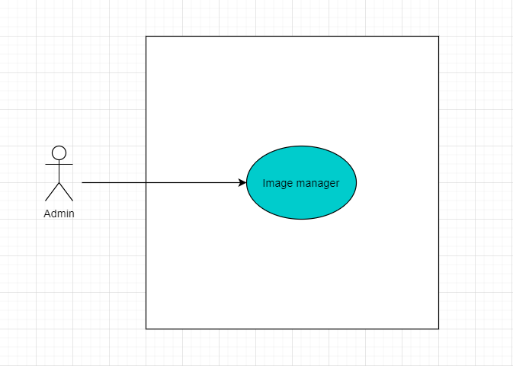

**Figure 3-15:** View Products Use-Case Diagram

|  |  |  |  |
| --- | --- | --- | --- |
| UC ID and Name: | UC-7 Image Manager | | |
| Created By: | Huynh Nhat Minh | Date Created: | 10/20/2020 |
| Primary Actor: | Admin | Secondary Actors: |  |
| Trigger: | N/A | | |
| Description: | **Add new Image:** Manager login to the “Dashboard”, on the homepage, the manager can add a new image by pressing the image management button on the left toolbar, click the add new image item.  **Edit Image:** Manager login to the “Dashboard”, on the homepage, the manager can edit an image by pressing the image management button on the left toolbar, select the edit image item.  **Delete Image:** Manager login to the “Dashboard”, on the homepage, the manager can delete an image by pressing the image management button on the left toolbar, select the delete image item. | | |
| Preconditions: | **PRE-1.1** Guest has a valid username and password | | |
| Postconditions: | **POST-1.1** When the normal flow completes successfully, a new image is added, updated, and deleted on the Dashboard page. | | |
| Normal Flow: | **Add new catalogs**:  1. Admin login to the Dashboard page.  2. Click the Product management section, choose to add a new image.  3. Fill in product information such as name, URL.  4. The system validation of the input data values.  5. Click the add a new image.  6. Show information successfully added.  **Edit catalogs:**  1. Admin login to the Dashboard page  2. Click the Product management section, choose to edit the image  3. Fill in product information such as name, URL.  4. The system validation the input data values  5. Click the edited image  6. Show information successfully edited  **Delete catalogs:**  1. Admin login to the Dashboard page.  2. Click the Product management section, choose to delete the image.  3. The system displays a confirmation message that you want to remove the image or not:  4. Click “Yes” or “No”  5.1 If click “Yes” show information successfully deleted.  5.2 If click “No” direction to Home Page. | | |
| Alternative Flows: | N/A | | |
| Exceptions: | System display "Error" | | |
| Priority: | Low | | |
| Frequency of Use: | Sometimes | | |
| Business Rules: | N/A | | |
| Other Information: | N/A | | |
| Assumptions: | N/A | | |

### 1.9 UC010 – Supplier Product

#### Screen Design

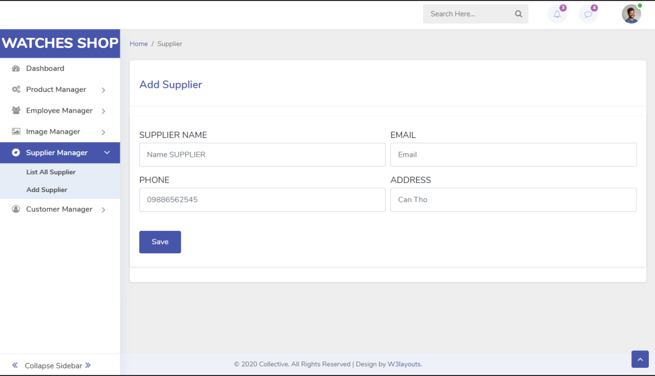

**Figure 3-16**: Screen Design of Add Supplier

#### Use Case Specification

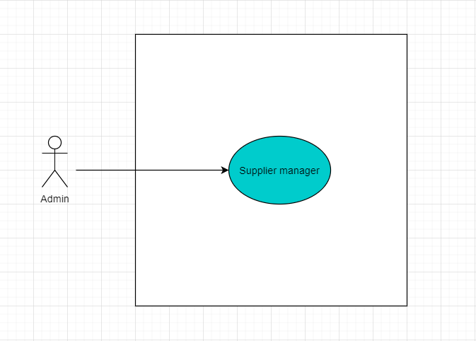

**Figure 3-17:** Supplier Manager Use-Case Diagram

|  |  |  |  |
| --- | --- | --- | --- |
| UC ID and Name: | UC-5 Supplier Manager | | |
| Created By: | Le Minh Nghia | Date Created: | 10/20/2020 |
| Primary Actor: | Admin | Secondary Actors: |  |
| Trigger: | Admin can add, edit, delete table Supplier | | |
| Description: | **Add new Supplier:** Manager login to the “Dashboard”, on the homepage, the manager can add a new Supplier by pressing the Supplier management button on the left toolbar, select the add new Supplier item.  **Edit Supplier:** Manager login to the “Dashboard”, on the homepage, the manager can edit a Supplier by pressing the Supplier management button on the left toolbar, select the edit Supplier item.  **Delete Supplier:** Manager login to the “Dashboard”, on the homepage, the manager can delete a Supplier by pressing the product management button on the left toolbar, select the delete Supplier item. | | |
| Preconditions: | **PRE-1.1** has login Dashboard success | | |
| Postconditions: | When the normal flow completes successfully, a new Supplier is added, updated, and deleted on the List Supplier page. | | |
| Normal Flow: | **Add a new Supplier**:  1. Admin login to a Dashboard page  2. Click the Supplier management section, choose to add a new Supplier  3. Fill in Supplier information  4. The system validation the input data values  5. Click the Add new Supplier  6. Show information successfully added  **Edit product:**  1. Admin login to a Dashboard page  2. Click the List Supplier in Menu section, choose to edit product want edit  3. Fill in Supplier information  4. The system validation the input data values  5. Click the edit Supplier  6. Show information successfully edited  **Delete product:**  1. Admin login to a Dashboard page  2. Click the List Supplier in Menu section, choose to edit product want remove  3. The system displays a confirmation message that you want to remove the product or not  4. Click “Yes” or “No”  5.1 If click “Yes” show information successfully deleted.  5.2 If click “No” direction to Home Page | | |
| Alternative Flows: | System display "Error" page with message "Internal System Error" | | |
| Exceptions: | System display "Error" | | |
| Priority: | High | | |
| Frequency of Use: | Every day | | |
| Business Rules: | N/A | | |
| Other Information: | N/A | | |
| Assumptions: | N/A | | |

### 1.10 UC011 – View Report

#### Screen Design

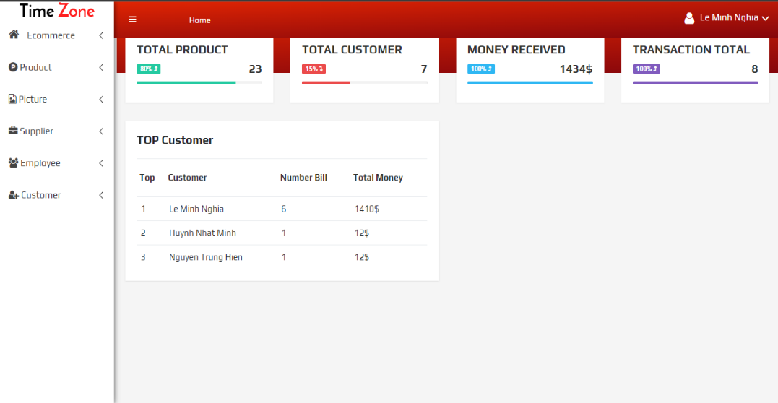

**Figure 3-18**: Screen Design of View Report a list of 3 customers who buy the most products

#### Use Case Specification

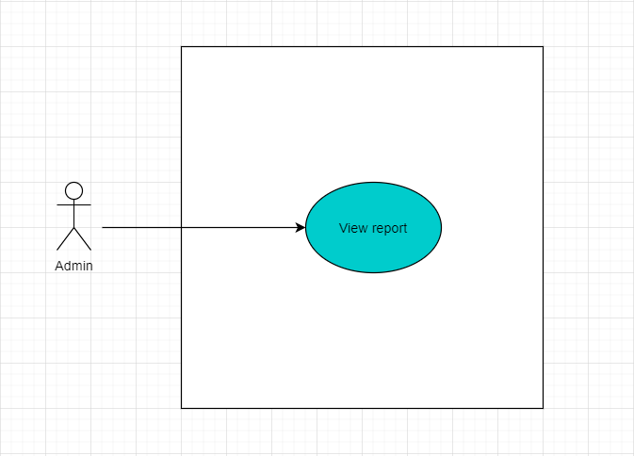

**Figure 3-19:** View Report Use-Case Diagram

|  |  |  |  |  |
| --- | --- | --- | --- | --- |
| UC ID and Name: | UC-6 Report Top Customer | | | |
| Created By: | | Le Minh Nghia | Date Created: | 10/20/2020 |
| Primary Actor: | | Admin | Secondary Actors: |  |
| Trigger: | | View Statistical | | |
| Description: | | The statistics table will be displayed in the Dashboard | | |
| Preconditions: | | **PRE-1.1** Login Dashboard success | | |
| Postconditions: | | When the normal flow completes successfully, the manager view types of reports monthly. | | |
| Normal Flow: | | **View details:**  1. Admin login dashboard page  2. Click view Statistical  3. Select statistics type: a weekly, monthly, customer who buys the most to view details.  4. Logout | | |
| Alternative Flows: | | System display "Error" page with message "Internal System Error" | | |
| Exceptions: | | System display "Error" | | |
| Priority: | | High | | |
| Frequency of Use: | | Sometimes | | |
| Business Rules: | | N/A | | |
| Other Information: | | N/A | | |
| Assumptions: | | N/A | | |

### 1.11 UC07 – Catelogies Manager

#### Screen Design

#### Use Case Specification

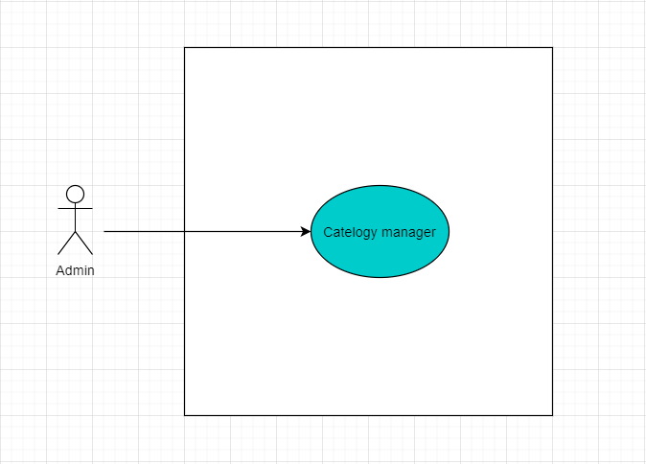

**Figure 3-20:** Catalog Manager Use-Case Diagram

|  |  |  |  |
| --- | --- | --- | --- |
| UC ID and Name: | UC-7 Categories Manager | | |
| Created By: | Huynh Nhat Minh | Date Created: | 10/20/2020 |
| Primary Actor: | Admin | Secondary Actors: |  |
| Trigger: | N/A | | |
| Description: | **Add new Categories:** Manager login to the “Dashboard”, on the homepage, the manager can add a new category by pressing the catalogs management button on the left toolbar, select the add new category item.  **Edit Categories:** Manager login to the “Dashboard”, on the homepage, the manager can edit a category by pressing the category management button on the left toolbar, select the edit category item.  **Delete Categories:** Manager login to the “Dashboard”, on the homepage, the manager can delete a category by pressing the product management button on the left toolbar, select the delete category item. | | |
| Preconditions: | **PRE-1.1** Guest has a valid username and password | | |
| Postconditions: | **POST-1.1** When the normal flow completes successfully, a new category is added, updated, and deleted on the Dashboard page. | | |
| Normal Flow: | **Add a new category**:  1. Admin login to the Dashboard page  2. Click the Product management section, choose to add a new category  3. Fill in product information such as name, descriptions.  4. The system validation the input data values  5. Click the Add new category  6. Show information successfully added  **Edit category:**  1. Admin login to the Dashboard page  2. Click the Product management section, choose to edit categories  3. Fill in product information such as name, descriptions.  4. The system validation the input data values  5. Click the edit categories  6. Show information successfully edited  **Delete category:**  1. Admin login to a Dashboard page  2. Click the Product management section, choose to delete the category.  3. The system displays a confirmation message that you want to remove the category or not  4. Click “Yes” or “No”  5.1 If click “Yes” show information successfully deleted.  5.2 If click “No” direction to Home Page | | |
| Alternative Flows: | N/A | | |
| Exceptions: | System display "Error" | | |
| Priority: | Low | | |
| Frequency of Use: | Sometimes | | |
| Business Rules: | N/A | | |
| Other Information: | N/A | | |
| Assumptions: | N/A | | |